**[SQL Project – Music Store Data Analysis](https://github.com/Prathamesh36/SQL_MUSIC_STORE_ANALYSIS)**

Data Analysis Project for Music Store to help how they can optimize their business opportunities and to help answering business related questions.

[**Music Store Datasets**](https://github.com/Prathamesh36/SQL_MUSIC_STORE_ANALYSIS/tree/main/Music%20Store%20Data)

[album.csv](https://github.com/Prathamesh36/SQL_MUSIC_STORE_ANALYSIS/blob/main/Music%20Store%20Data/album.csv) [album2.csv](https://github.com/Prathamesh36/SQL_MUSIC_STORE_ANALYSIS/blob/main/Music%20Store%20Data/album2.csv)

[Artist.csv](https://github.com/Prathamesh36/SQL_MUSIC_STORE_ANALYSIS/blob/main/Music%20Store%20Data/artist.csv) [customer.csv](https://github.com/Prathamesh36/SQL_MUSIC_STORE_ANALYSIS/blob/main/Music%20Store%20Data/customer.csv)

[Employee.csv](https://github.com/Prathamesh36/SQL_MUSIC_STORE_ANALYSIS/blob/main/Music%20Store%20Data/employee.csv) [genre.csv](https://github.com/Prathamesh36/SQL_MUSIC_STORE_ANALYSIS/blob/main/Music%20Store%20Data/genre.csv)

[Invoice.csv](https://github.com/Prathamesh36/SQL_MUSIC_STORE_ANALYSIS/blob/main/Music%20Store%20Data/invoice.csv) [invoice_line.csv](https://github.com/Prathamesh36/SQL_MUSIC_STORE_ANALYSIS/blob/main/Music%20Store%20Data/invoice_line.csv)

[media_type.csv](https://github.com/Prathamesh36/SQL_MUSIC_STORE_ANALYSIS/blob/main/Music%20Store%20Data/media_type.csv) [playlist.csv](https://github.com/Prathamesh36/SQL_MUSIC_STORE_ANALYSIS/blob/main/Music%20Store%20Data/playlist.csv)

[playlist_track.csv](https://github.com/Prathamesh36/SQL_MUSIC_STORE_ANALYSIS/blob/main/Music%20Store%20Data/playlist_track.csv) [track.csv](https://github.com/Prathamesh36/SQL_MUSIC_STORE_ANALYSIS/blob/main/Music%20Store%20Data/track.csv)

**Schema Diagram**

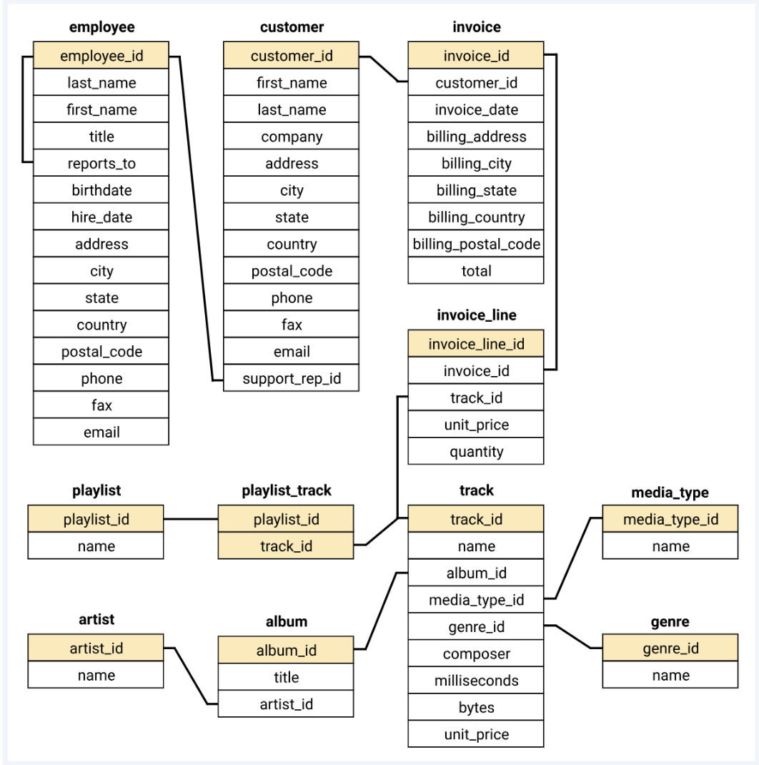

**Database and Tools**

* PostgreSQL
* pgAdmin4

**Questions for the project**

1. Who is the senior most employee based on job title?

2. Which countries have the most Invoices?

3. What are top 3 values of total invoice?

4. Which city has the best customers? We would like to throw a promotional Music Festival in the city we made the most money. Write a query that returns one city that has the highest sum of invoice totals. Return both the city name & sum of all invoice totals

5. Who is the best customer? The customer who has spent the most money will be declared the best customer. Write a query that returns the person who has spent the most money

6. Write query to return the email, first name, last name, & Genre of all Rock Music listeners. Return your list ordered alphabetically by email starting with A

7. Let's invite the artists who have written the most rock music in our dataset. Write a query that returns the Artist name and total track count of the top 10 rock bands

8. Return all the track names that have a song length longer than the average song length. Return the Name and Milliseconds for each track. Order by the song length with the longest songs listed first

9. Find how much amount spent by each customer on artists? Write a query to return customer name, artist name and total spent

10. We want to find out the most popular music Genre for each country. We determine the most popular genre as the genre with the highest amount of purchases. Write a query that returns each country along with the top Genre. For countries where the maximum number of purchases is shared return all Genres

11. Write a query that determines the customer that has spent the most on music for each country. Write a query that returns the country along with the top customer and how much they spent. For countries where the top amount spent is shared, provide all customers who spent this amount

**Questions and Answers (Queries)**

***1. Who is the senior most employee based on job title?***

* select first_name, last_name, levels from employee order by levels desc limit 1;



***2. Which countries have the most Invoices?***

* select billing_country,count(*) as Total_count from invoice

group by billing_country

order by Total_count desc;

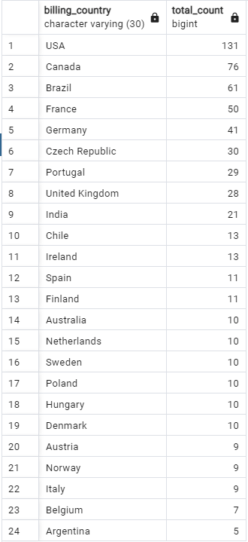

***3. What are top 3 values of total invoice?***

* select total from invoice

order by total desc

limit 3;

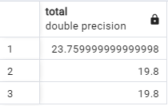

***4. Which city has the best customers? We would like to throw a promotional Music Festival in the city we made the most money. Write a query that returns one city that has the highest sum of invoice totals. Return both the city name & sum of all invoice totals***

* select billing_city as city, sum(total) as total_sum from invoice

group by city

order by total_sum desc

limit 1;

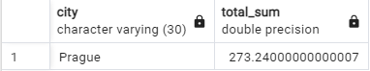

***5. Who is the best customer? The customer who has spent the most money will be declared the best customer. Write a query that returns the person who has spent the most money***

* select c.customer_id, c.first_name, c.last_name, sum(i.total)as money_spent

from customer as c

join invoice as I on c.customer_id=i.customer_id

group by c.customer_id

order by money_spent desc

limit 1;

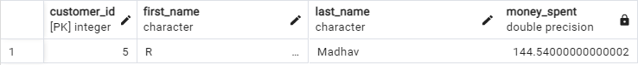

***6. Write query to return the email, first name, last name, & Genre of all Rock Music listeners. Return your list ordered alphabetically by email starting with A***

* select distinct email,first_name, last_name

from customer

join invoice on customer.customer_id=invoice.customer_id

join invoice_line on invoice.invoice_id=invoice_line.invoice_id

where track_id in(

select track_id from track

join genre on track.genre_id=genre.genre_id

where genre.name = 'Rock'

)

order by email ;

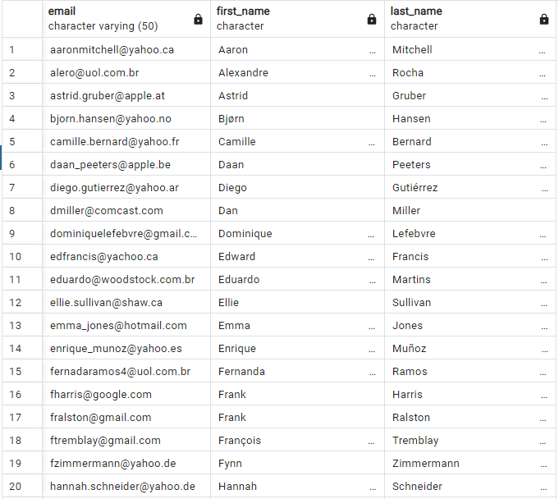*top 20 records only

***7. Let's invite the artists who have written the most rock music in our dataset. Write a query that returns the Artist name and total track count of the top 10 rock bands***

* select artist.artist_id,artist.name, count(artist.artist_id)as total_count from artist

join album on artist.artist_id=album.artist_id

join track on album.album_id=track.album_id

join genre on track.genre_id=genre.genre_id

where genre.name ='Rock'

group by artist.artist_id

order by total_count desc

limit 10;

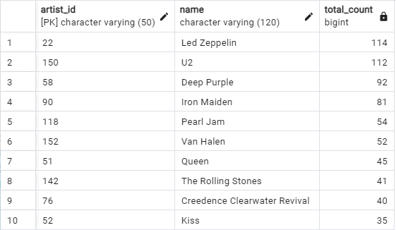

***8. Return all the track names that have a song length longer than the average song length. Return the Name and Milliseconds for each track. Order by the song length with the longest songs listed first***

* select name, milliseconds from track

where milliseconds >(

select avg(milliseconds) from track

)

order by milliseconds desc;

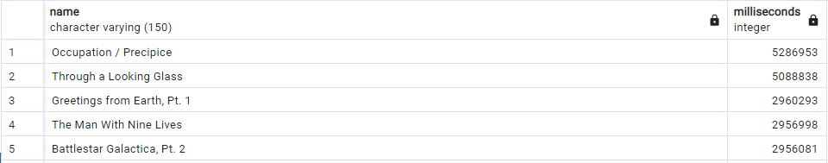…

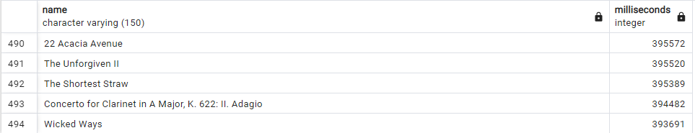

*top 5 and bottom 5 records

***9. Find how much amount spent by each customer on artists? Write a query to return customer name, artist name and total spent***

* with best_selling_artist AS (

SELECT artist.artist_id AS artist_id, artist.name AS artist_name,

SUM(invoice_line.unit_price*invoice_line.quantity) AS total_sales

FROM invoice_line

JOIN track on track.track_id = invoice_line.track_id

JOIN album ON album.album_id = track.album_id

JOIN artist ON artist.artist_id = album.artist_id

Group BY 1

ORDER BY 3 DESC

LIMIT 1

)

SELECT c.customer_id,c.first_name, c.last_name, bsa.artist_name,

SUM (il.unit_price*il.quantity) As amount_spent

FROM invoice i

JOIN customer c ON c.customer_id = i.customer_id

JOIN invoice_line il ON il.invoice_id = i.invoice_id

JOIN track t on t.track_id =il.track_id

JOIN album alb ON alb.album_id = t.album_id

JOIN best_selling_artist bsa ON bsa.artist_id =alb.artist_id

GROUP BY 1,2,3,4

ORDER BY 5 DESC;

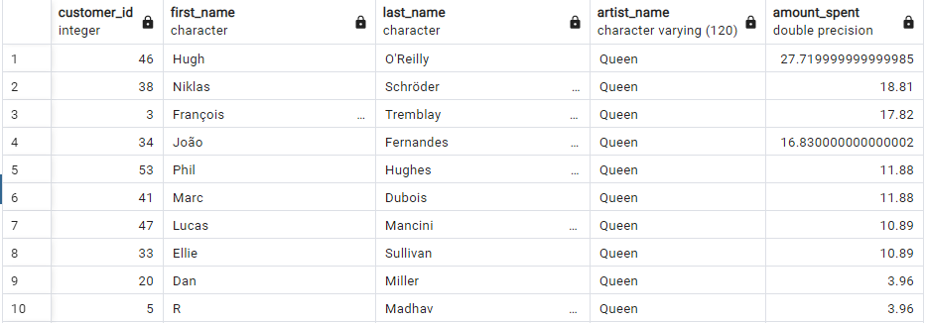*top 10 records only

***10. We want to find out the most popular music Genre for each country. We determine the most popular genre as the genre with the highest amount of purchases. Write a query that returns each country along with the top Genre. For countries where the maximum number of purchases is shared return all Genres***

* WITH popular_genre AS (

SELECT COUNT(invoice_line.quantity) AS purchases, customer.country, genre.name,genre.genre_id,

ROW_NUMBER() OVER ( PARTITION BY customer.country ORDER BY COUNT (invoice_line.quantity) DESC) AS RowNo

FROM invoice_line

JOIN invoice ON invoice.invoice_id = invoice_line.invoice_id

JOIN customer ON customer.customer_id =invoice.customer_id

JOIN track ON track.track_id = invoice_line.track_id

JOIN genre ON genre.genre_id = track.genre_id

GROUP by 2,3,4

ORDER BY 2 ASC , 1 DESC

)

SELECT * from popular_genre WHERE RowNo <= 1

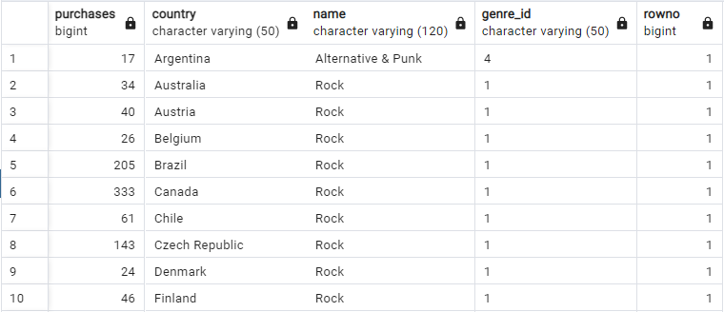

*top 10 records only

***11. Write a query that determines the customer that has spent the most on music for each country. Write a query that returns the country along with the top customer and how much they spent. For countries where the top amount spent is shared, provide all customers who spent this amount***

* with Customer_with_country AS (

SELECT customer.customer_id,first_name, last_name,billing_country,SUM(total) AS total_spending,

ROW_NUMBER() OVER (PARTITION BY billing_country ORDER BY SUM(total) DESC) AS RowNo

FROM invoice

JOIN customer ON customer.customer_id = invoice.customer_id

GROUP BY 1,2,3,4

ORDER BY 4 ASC, 5 DESC

)

SELECT * FROM Customer_with_Country WHERE RowNo <= 1;

